**Percentile Report**

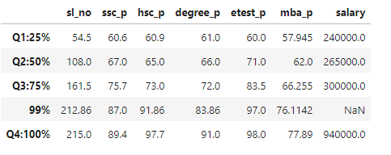

**ssc_p**:

* 25% of the students scored 60.6%.
* 50% of the students scored 67.0%.
* 75% of the students scored 75.7%.
* 99% of the students scored 87.0%.
* The highest SSC percentage recorded is 89.4%.
* There is a steady increase in SSC percentages. Average of increasing around 7 to 12%.

**Hsc_p:**

* 25% of the students scored 60.9%
* 50% of the students scored 65%
* 75% of the students scored 73.0%
* 99% of the students scored 91.86%
* The highest HSC percentage recorded is 97.7%
* Average of increasing from Q1 to Q3 around 5 to 13% and Q3 to Q4 is 18%.

**Degree_P:**

* 25% of the students scored 61%
* 50% of the students scored 66%
* 75% of the students scored 72%
* 99% of the students scored 83.86%
* The highest Degree percentage recorded is 91%
* Average of increasing from Q1 to Q3 around 5 to 6% and Q3 to Q4 is 11%.

**Estest_P:**

* 25% of the students scored 60%
* 50% of the students scored 71%
* 75% of the students scored 83.85%
* 99% of the students scored 97%
* The highest entrance test percentage recorded is 98%
* Average of increasing from Q1 to Q4 around 10 to 14%.

**Mba_p:**

* 25% of the students scored 57.94%
* 50% of the students scored 62%
* 75% of the students scored 66.25%
* 99% of the students scored 76.11%
* The highest entrance test percentage recorded is 77.89%
* Average of increasing from Q1 to Q3 around 5 % and Q3 to Q4 is 10%.

**Salary:**

* 25% of the students placed on salary 240000.
* 50% of the students placed on salary is 265000.
* 75% of the students placed on salary is 300000.
* Students placed highest salary is 940000.